**DAILY ONLINE ACTIVITIES SUMMARY**

|  |  |  |  |  |  |  |  |
| --- | --- | --- | --- | --- | --- | --- | --- |
| **Date:** | **25-05-2020** | | | | **Name:** | **RAVALI P** | |
| **Sem & Sec** | **6 B** | | | | **USN:** | **4AL17CS076** | |
| Online Test Summary | | | | | | | |
| **Subject** | | **No IA tests held on 25th** | | | | | |
| **Max. Marks** | |  | | **Score** | |  | |
| Certification Course Summary | | | | | | | |
| **Course** | **CARRER EDGE** | | | | | | |
| **Certificate Provider** | | | **TCS** | **Duration** | | | **15 DAYS** |
| Coding Challenges | | | | | | | |
| **Problem Statement-no coding programs are given on that day .** | | | | | | | |
| **Status:no.** | | | | | | | |
| **Uploaded the report in Github** | | | | **Yes** | | | |
| **If yes Repository name** | | | | **https://github.com/Ravalipr/Daily-Status.git** | | | |
| **Uploaded the report in slack** | | | | **Yes** | | | |

Online Test Details: (Attach the snapshot and briefly write the report for the same)

* No test held on 25th

Certification Course Details: (Attach the snapshot and briefly write the report for the same)

* In this course today I have learnt about the how to deliver a presentation.
* What are all the points we need to put on the slide while delivering a presentation.
* And the other topic about the development of Soft Skills and how to communicate with others in the work place.
* Atlast they have given assignment.

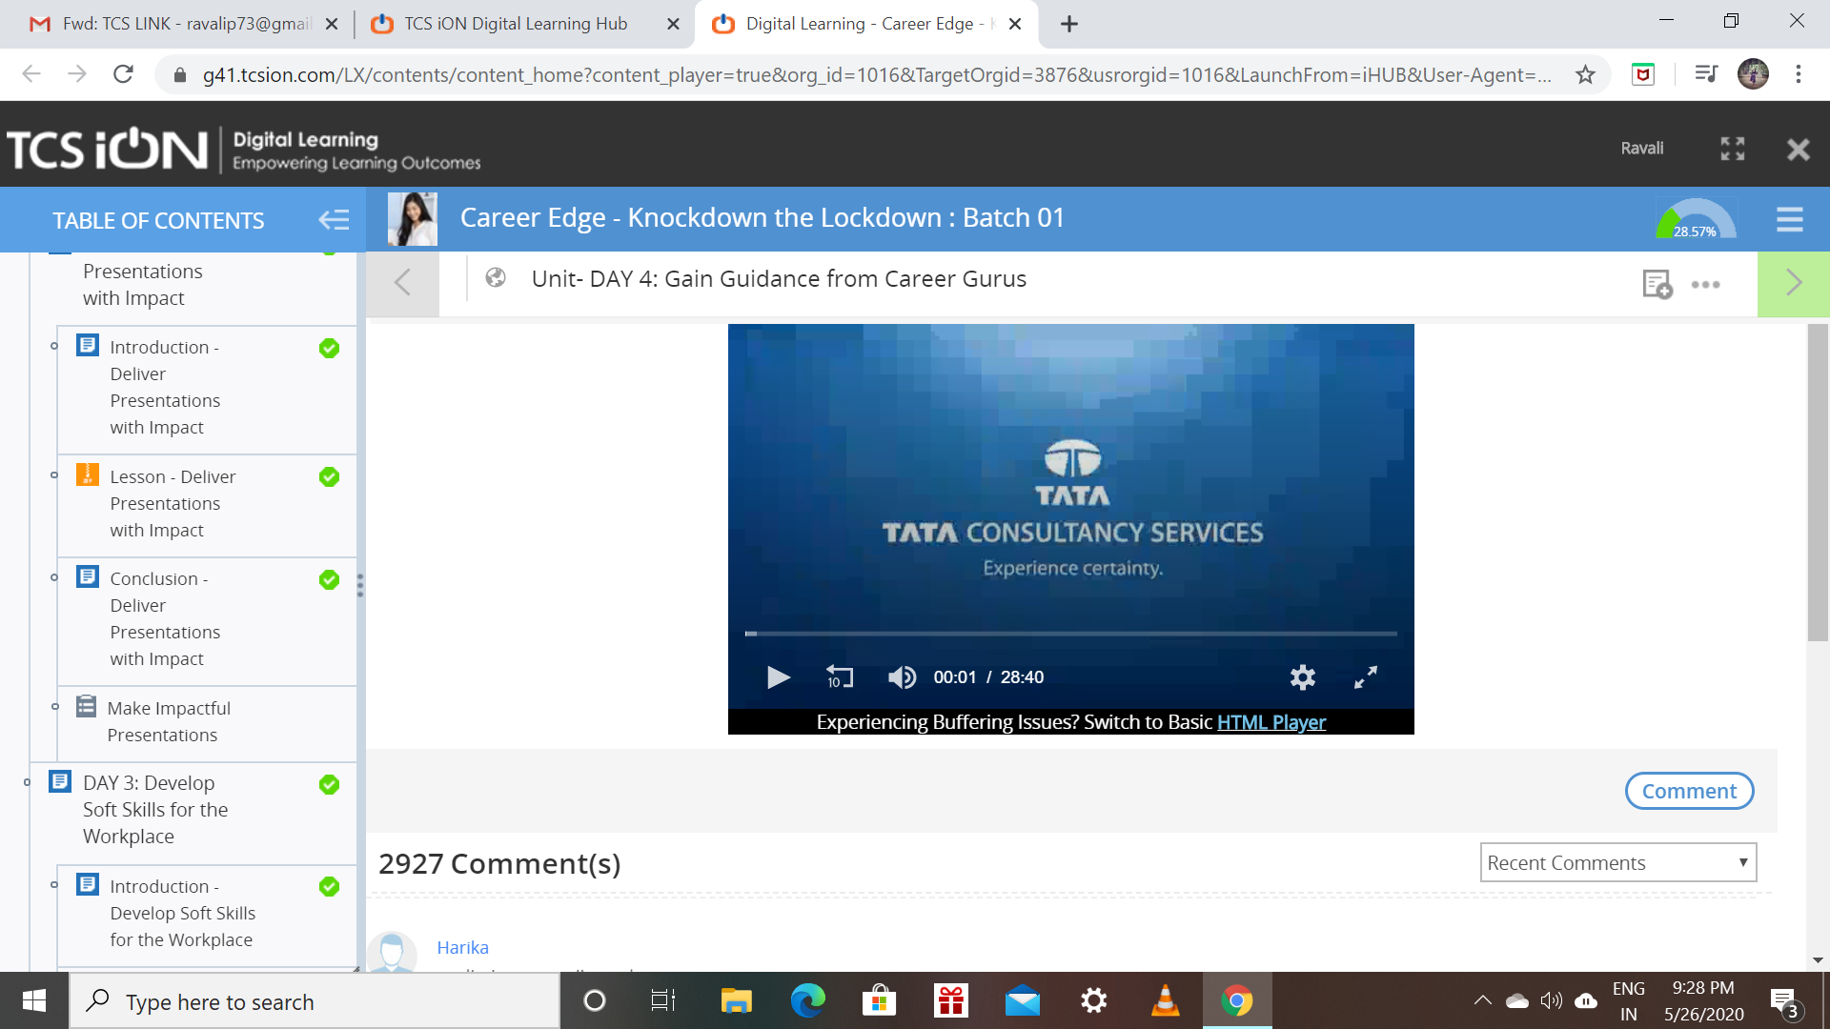

Coding Challenges Details: (Attach the snapshot and briefly write the report for the same)

No programs are given to solve on that day.